**ILDHS Hotline**

Standard Operation Procedures

2024

**Revised: 10.29.2024**

Table of Contents

Step by step on how to: ____________________________________ 3

DHS Hotline: _____________________________________________ 3

Information needed to request recipient’s eligibility status: _______ 4

When Recipient’s Eligibility status provided: ____________________ 5

Identify the hospital: ______________________________________ 6

Identify patient’s information: _______________________________ 7

How to find Case ID/T number_______________________________ _7

Identify the date of service: _________________________________ 7

How to send “User Task”: ___________________________________ 8

How to send “User Note”: __________________________________ 9

Record of Birth (IL 444-2636): _______________________________ 11

Patient Queue: ___________________________________________ 14

Provider ID Number: ______________________________________ 16

RS (Resolution Specialist): _________________________ 17

Note and “User Task” templates: _______ 19

**Step by step on how to:**

1. Use Patient Queue to pull information needed to request recipient’s eligibility status.
   1. Identify the hospital information and find appropriate provider number
   2. Identify patient’s (recipient’s) information / use record of birth for newborn babies
   3. Identify date of service
   4. Call DHS hotline
   5. Obtain eligibility status
   6. Identify RS
   7. Status Agency / send user task

**DHS Hotline:**

Use DHS hotline for questions about case status, benefits, services and eligibility. DHS hotline can provide up to five client eligibility status. DHS hotline will only provide update on existing status, it will not make changes or corrections.

*\*\*\* Appropriate* *PROVIDER NUMBER* *must be used for specific facility.*

Call DHS Hotline at: **1-800-842-1461**

* Enter your provider number follow by “#”key
* Press “1” to confirm, press “2” to correct
* Press “1” to access recipient eligibility information
* Press “0” to speak to the operator
* Press “1” to enter your provider number follow by the “#’ key
* Please hold for the next available representative.
  + Approximate hold time 45/60 minutes
* Once hotline representative answers the call:
  + Provide Provider Number
  + Provide name of the Facility
* DHS representative can provide status for up to five clients.
* DHS representative will ask for information that will help in finding the client’s eligibility. Please refer to “Information needed to request recipient’s eligibility status” section for more information.
  + Provide as many information as needed to find client in DHS system.
  + For minor children, provide guardian’s information as well as the child.
* When calling hotline, if you hear a message:
  + “due to the high volume of calls, we are unable to take your call before close of business day today”
    - Hang up and call again until the call goes through.
* Have all needed information available when calling hotline as DHS representative has limited time and will not wait/assist if the information is not presented at the time of the call.

**Information needed to request recipient’s eligibility status:**

* Adult
  + Social security number
  + Date of birth
  + Name
  + Application tracking number
  + Case ID number
  + Date of service
  + Individual ID
* Minor
  + Parent’s social security number
  + Parent’s date of birth
  + Parent’s name
  + Child’s name
  + Application tracking number
  + Case ID number
  + Parent’s RIN
  + Date of service
  + Individual ID
* MANG-Newborn
  + Mom’s Case ID number
  + Mom’s name
  + Baby’s date of birth
  + Individual ID

**Additional questions to ask when:**

* If case was approved:
  + Obtain RIN (Recipient’s ID Number)
* If case was denied:
  + Obtain Denial reason
  + Obtain denial date
  + Verify if any other application is pending
    - If yes, what is the application date and Case ID
  + Obtain Individual ID
* If case was not found/canceled:
  + Obtain cancelation reason
  + Obtain cancelation date
  + Verify in any other application is pending
    - If yes, what is the application date and Case ID

**When Recipient’s eligibility status provided:**

1. Update PACE
   1. Case Pending:
      * 1. Case ID number
        2. Date of application
        3. Status of the application
   2. Case Not Found/Canceled:
      1. Send “User Task” to RS with detailed message:
         1. Tracking number
         2. Application date
         3. Status of application
         4. Recipient’s eligibility status
         5. Exclude MANG Newborn applications from sending User Task
   3. Case Denied:
      1. Send “User Task” to RS with detailed message:
         1. Tracking number
         2. Application date
         3. Status of application
         4. Denial date (if provided)
         5. Denial reason (if provided)
         6. Recipient’s eligibility status
   4. Case Approved:
      1. Send “User Task” to RS with detailed message:
         1. Eligibility status
         2. RIN
         3. Coverage range date
         4. System date
   5. If case is approved but needs a backdate (doesn’t cover our DOS)
      1. Provide future dates to obtain RIN
      2. Example: DOS (admit-to-discharge dates) is 5/8/19-5/10/19; DHS Representative stated, “not eligible for DOS and case needs to be backdated”. User should provide DHS representative DOS for future months (7/819,8/8/19,9/8/19) to obtain RIN.

**\*\*Important\*\***

* Please review the case history prior to sending a user task. If a status was obtained and user task was previously set and subsequently marked as “completed” by the CHC Onshore team DO NOT set additional User Tasks for the same status. A “user note” should still be placed into the system following the above guidelines. However, additional language should be included: “previous task marked as completed, no additional tasks will be set at this time”.

**How to Identify a “Completed” user task**

On the left-hand side of PACE locate “view history” and click it

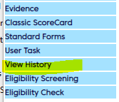

* You should then be able to identify when your user task was submitted and when it was completed by the On Shore team by looking for these key items:
* Under Activity – it will say user task under activity but there will be no results – this should indicate the user task that was sent to another user
* When the On-Shore team addresses that task, it will say “contact initiated” under result



Additionally, when you hover over the sticky note, it will show the status as well as the user that assigned the task. If the status is marked as “completed” and the update being placed in the system is identical to the completed task, do NOT place another task, only a note.

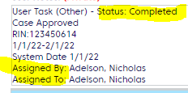

**Identify the hospital**

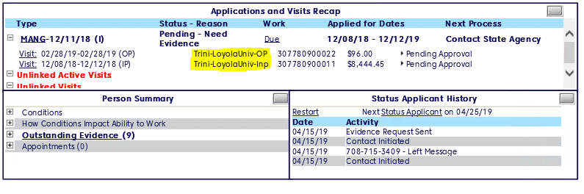

**Identify patient’s information**

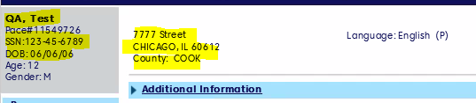

**Find Case ID/T #**

* Click on “application type”

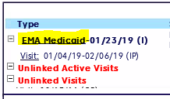

* Please find your Case ID/T # under “Case Number”

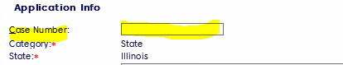

**Identify the date of service**

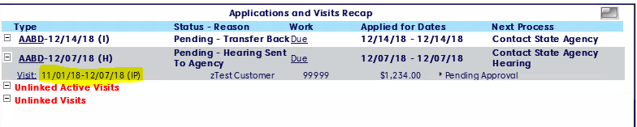

**How to send “User Task”:**

1. Click on “User Task”

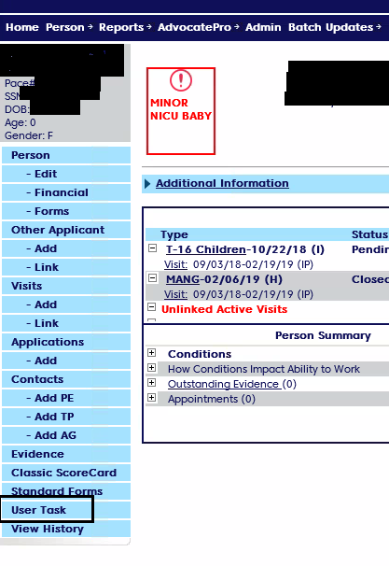

1. Under “*User*” type assigned RS name
2. Under “*Detai*l”, include your detailed note
3. Mark the “*priority*” as:
   1. “*High*”-for approved or denied

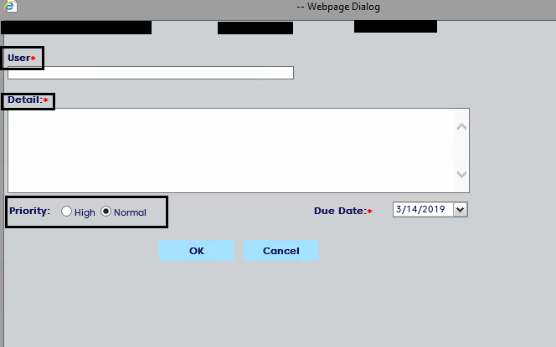

1. Write your message:
2. For **Denied** case use note:
   1. Called DHS Hotline. Case denied, Case ID/Tracking# _________________, application date ___________.
3. For **Approved** case use note:
   1. Called DHS Hotline. Case approved for date of service _____________ with Case ID #_____________, RIN ________________, application date ______________.

**How to enter “User Note”**

1. Click on “Application type”

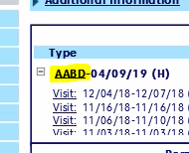

1. In the right corner click on the “sticky note” and type your note
   1. Called DHS hotline, case pending with Case ID _____________, since ______________.
      1. Add any additional information you can obtain

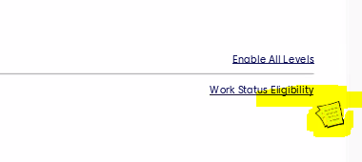

1. Select the message “Private” and “High Importance”

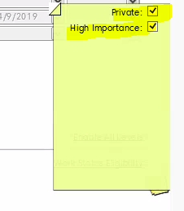

1. Save

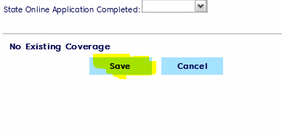

**Record of Birth (IL 444-2636)**

**Where to find 2636:**

1. 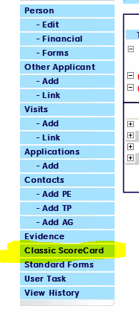
2. 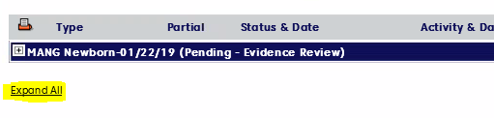
3. 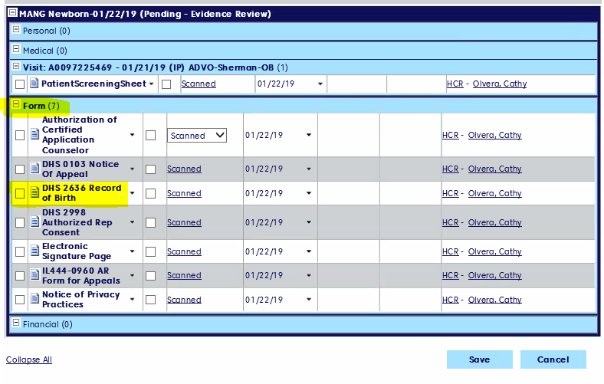

**How to read and use 2636 when calling Hotline:**

1. Mother’s information available:
   1. Case Number
   2. Mother’s Full Name
   3. Mother’s Social Security Number
   4. Mother’s birth date
   5. Mother’s Recipient Number
2. Newborn baby information available:
   1. Baby’s full name
   2. Date of Birth
   3. Sex
3. Information needed to obtain eligibility on MANG-Newborn
   1. *Under Case Number*- last 9 digits of the Case ID Number
   2. *Under Mother’s Full Name*- first and last name of the mother
   3. *Under Date of Birth*- Newborn’s date of birth
   4. Date of service will be from the date of birth ongoing
      1. If newborn is eligible but not for the date of service provide future dates to obtain RIN

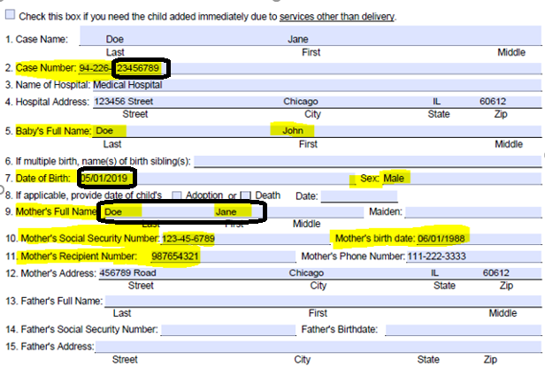

NOTE – If no DHS 2636 Record of Birth scanned into PACE, please see the two options below on where to find mother’s information:

1. Click on Edit option under Person and find the highlighted information needed in the field’s marked yellow (Alias refers to mother’s case number)

1. Please review the notes that are accessed under View History.

The notes will include all the mother’s information needed as shown below:

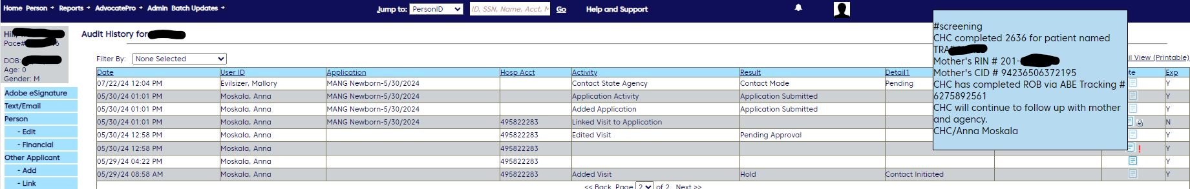

1. A screenshot of a document

   Description automatically generatedUnder score card please review uploaded files and find the Record of Birth that was submitted to the state and locate mother’s needed information as shown below:
2. If no mother's information is located please notate the account, and send an email to the manager: Norma Arellano ([narellano@optum.com](mailto:narellano@optum.com)) and Fernando Martinez ([fernando_martinez@optum.com](mailto:fernando_martinez@optum.com)) with title MANG Newborn information missing, in the e-mail send the hospital name and PID for the client.

**Patient Queue**

1. Click “*Home*”

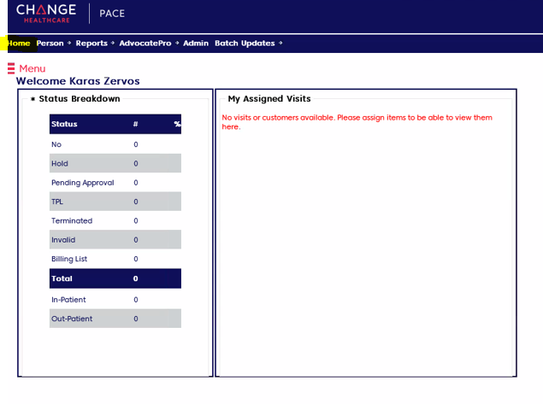

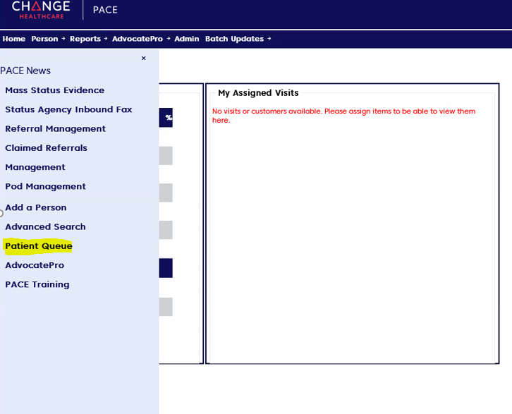

1. The patient Queue will appear

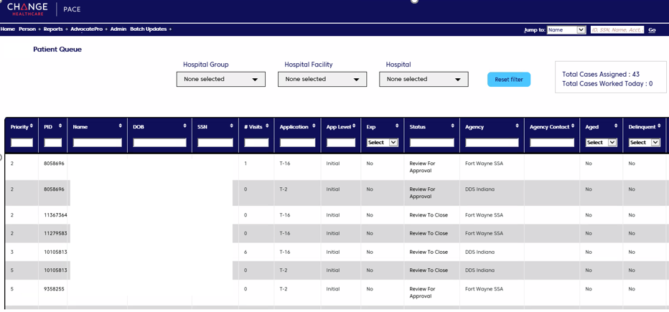

**Provider ID Number:**

Rush University Medical Center- 1932213600

Northwestern Memorial Hospital- 1497859649

Loyola University Medical Center- 1376521575

Advocate Christ Medical Center- 1548375082

Advocate Condell Medical Center- 1124272547

Advocate Good Samaritan Hospital- 1578670543

Advocate Good Shepherd Hospital- 1447368071

Advocate Illinois Masonic Medical Center- 1912014564

Advocate Health and Hospitals Corporation- 1558479212

Advocate Lutheran General Hospital- 1164539730

Advocate South Suburban Hospital- 1467560128

Advocate Sherman Hospital – 1629026364

Trinity-Gottlieb Memorial Hospital - 1831170232

Trinity-Loyola University Medical Center - 1376521575

Trinity-MacNeal Hospital - 1376521575

Trinity SJ-St. Joseph's Hospital Syracuse - 1508815333

**Resolution Specialist**

**To determine RS name on application:**

1. Click on the name of the application

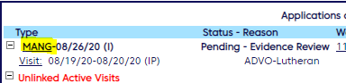

2. Look for RS name listed under application info.

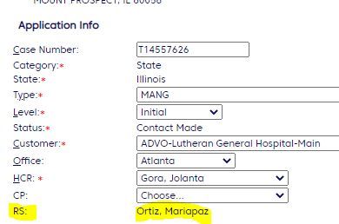

|  |  |  |
| --- | --- | --- |
| **Scenarios** | **Documentation** | |
| **Note Type** | **Message Type** |
| Case Approved | User Task | High |
| Case Denied(first touch) | User Task | High |
| Case Denied(within 30 Days Follow-up) | User Note | High Importance and Private |
| Case Denied(after 30 Days Follow-up) | User Task | High |
| Case Pending | User Note | High Importance and Private |
| Case Closed/Cancelled | User Task | Normal |
| Case Not Found | User Note | Normal |
| Case Not Added | User Note | High Importance and Private |
| Retro Request | User Note | High Importance and Private |
| Case Duplicate | User Note | High Importance and Private |
| Case RPY/QMB/SNAP/Spendown | User Note | High Importance and Private |
| Case not Eligible | User Note | High Importance and Private |

**User note and task Templates:**

**Denied for all app types:**

Denied-Called DHS hotline at 1-800-842-1461 and spoke with **XXXX**. Application # **XXXXXXXXXX**  was received on **XX/XX/XXXX** and it was denied on **XX/XX/XXXX.** The reason for the exact denial is not available in their system. (VERIFY IF ANY OTHER APPLICATIONS PENIDNG) Also, there is no other active or pending Applications found for this patient. Need to contact the local office for more information. Case Number-**XXXXXXXX**. call reference-**XXXXXXXXXX**

**Approved for all app types:**

Approved-Called DHS hotline at 1-800-842-1461 and spoke with **XXXX**. Case was Approved. RIN: **XXXXXXXXX** (Traditional Medicaid) and effective on the DOS **(XX/XX/XXXX).** No other information provided. Case number-**XXXXXXXX** call reference-**XXXXXXXXX**.

**Pending all app types:**

Called DHS hotline at 1-800-842-1461 and spoke with Cynthia. Application was associated. Application # **XXXXXXXXXX** was received on **XX/XX/XXXX** and still pending at **XXXXXXXXX** (name of local office) office. Reason for delay in pending is not available in their system. Need to contact local office for more information. Associated Case number- **XXXXXXXX**. call reference- **XXXXXXXX**.

**Claim or claimant not found:**

Called DHS hotline 1-800-842-1461 and spoke with **XXXXXXX**. Patient was not found by SSN or Name and DOB. No other information provided. call reference - **XXXXXXXX**